Article

**Plant disease identification based on FoldNet, an improved lightweight network model architecture**

Wengfeng Feng 1, Qiushuang Song 2 and YYYY 2,*

|  |
| --- |
| **Citation:** To be added by editorial staff during production.  Academic Editor: Firstname Lastname  Received: date  Accepted: date  Published: date  **Publisher’s Note:** MDPI stays neutral with regard to jurisdictional claims in published maps and institutional affiliations.    **Copyright:** © 2022 by the authors. Submitted for possible open access publication under the terms and conditions of the Creative Commons Attribution (CC BY) license (https://creativecommons.org/licenses/by/4.0/). |

1 Affiliation 1; e-mail@e-mail.com

2 Affiliation 2; e-mail@e-mail.com

**\*** Correspondence: e-mail@e-mail.com; Tel.: (optional; include country code; if there are multiple corresponding authors, add author initials)

**Abstract:** In the field of precision agriculture, the identification of plant diseases has been one of the issues of great interest to researchers. In today's world, agricultural products are becoming increasingly scarce globally due to a variety of factors, and the early and accurate automatic identification of plant diseases can help ensure the stability and sustainability of agricultural production, improve the quality and safety of agricultural products, and also help promote agricultural modernization and sustainable development. For this purpose, a lightweight deep isotropic neural network model, FoldNet is designed for plant disease identification in this study. The model is based on the ResNet backbone network, which has multiple directly connected paths throughout the network, and the model can explore deeper networks, which can also identify plant disease features more accurately. In addition, the FoldNet model was validated on the laboratory dataset PlantVillage and the realistic scene dataset FGVC8, respectively, and the experimental results showed that the accuracy was 99.84% on the PlantVillage validation set and 90.49% on the FGVC8 validation set. Compared with other methods, the FoldNet model requires less than 1M parameters and the lowest computation time to produce best results and has outstanding robustness. Therefore, the model is applicable to mobile terminals for plant disease identification and can facilitate the development of precision agriculture applications.

**Keywords:** Plant disease identification; Deep learning; Deep Isotropic; Precision agriculture;

1. Introduction

Plant diseases are one of the major causes of crop yield reduction and quality deterioration. With today's dramatic global population growth expected to reach 9.7 billion by 2050, there is an urgent need to find new ways to improve the yield and quality of agricultural products to meet the massive demand of a growing population[1]. smart farming, as a new technology, aims to improve the efficiency and sustainability of agriculture by using data and advances technologies to make more informed, data-driven decisions about crop production and resource management[2]. By quickly and accurately identifying plant diseases, you can not only prevent the spread of plant diseases and protect the quality of plants, but also increase farmers' income and reduce the cost of plant disease treatment. In general, early, rapid and accurate disease identification and control can reduce the negative impact on the environment, and the use of fewer chemicals and pesticides can reduce water and soil contamination. Consequently, it is necessary to study an efficient, accurate and strongly robust automatic plant disease identification method, which is important to help farmers identify plant diseases and improve plant yield and quality.

In plant disease identification, image processing algorithms and traditional machine learning algorithms were commonly used in the early stages to identify plant diseases. In plant disease recognition, image processing algorithms and traditional machine learning algorithms were commonly used in the early stages to identify plant diseases[3], always through image pre-processing to improve image quality, then segmenting leaves, fruits or flowers from the background and separating healthy areas from diseased areas, then using statistical methods for feature extraction, and finally using supervised classification algorithms or unsupervised clustering algorithms to classify the features. Islam et al.[4] used Image Segmentation and Multiclass SVM for the identification of three types of plant diseases of potato. Agrawal et al.[5] used K-means to segment the image into three clusters and selected the cluster containing the lesion points, then extracted texture and color features from the clusters, then finally used Multiclass SVM to classify the grape leaf diseases. Dhakate et al.[6] presented a system to identify and classify four classes of pomegranate diseases using back propagation algorithm, which first preprocessed the images and k-means clustering segmentation, then used GLCM method to extract texture features, and finally used ANN to classify the diseases. Al-Hiary et al.[7] similarly used ANN classifier to classify five classes of leaf diseases and one class of normal leaves. Kaushal et al.[8] proposed a method to identify plant diseases using KNN classifier instead of SVM classifier, which first used GLCM for texture feature extraction, followed by K-means clustering algorithm for image segmentation, and eventually used KNN classifier for plant disease classification. Majumdar et al.[9] proposed a method for detection and identification of wheat rust images using fuzzy c-means clustering method. Although machine learning has made great achievements in image recognition, there are still some restrictions, such as they can only focus on specific disease types and require manual observation, resulting in low accuracy and efficiency. Moreover, these methods can only be performed on small data sets[10]. With the development of artificial intelligence, the application of deep learning algorithms in plant disease identification has achieved remarkable results, especially convolutional neural networks (CNN), which do not require pre-required processes such as segmentation and feature extraction, and can automatically learn features in images as well as have excellent robustness and generalization ability[11].

In recent years, much research in the field of deep learning-based plant disease identification and classification has been conducted utilizing a migration learning approach, which typically involves using a pre-trained classical network model as the initial model and then fine-tuning it to adapt to plant disease datasets to solve plant disease identification and classification problems. Sagar et al.[12] used the pre-trained models InceptionV3, InceptionResNetV2, ResNet50, MobileNet and Densenet169 to classify plant disease images in the PlantVillage dataset containing 38 classes by fine-tuning the last layer of the network model, and finally ResNet50 achieved the highest accuracy of 0.982. Mohanty et al.[13] similarly used the PlantVillage dataset with 38 classes and employed the classical network models AlexNet and GoogLeNet, and then adopted both migration learning and ab initio training methods to classify plant disease images, eventually with the migration learning training method, GoogLeNet achieved the highest 99.35% test accuracy. Nevertheless, the method has some limitations, firstly, the accuracy of the model is substantially reduced when tested for images taken from realistic scenes; secondly, it is limited by the homogeneous background and oriented to the classification of individual leaves; finally, the proposed method can only be used as a complement to existing solutions for disease diagnosis. Brahimi et al.[14] also implemented classification of nine tomato disease leaf images extracted from the PlantVillage public dataset using pre-trained AlexNet and GoogleNet, and used visualization methods to understand symptoms and oclusion techniques to locate disease regions in the leaves.Too et al.[15] equally used plant disease images from the PlantVillage dataset containing 38 classes for classification, in which various classical networks such as VGG-16, Inception V4, DenseNets-121, ResNet-50, ResNet-101, and ResNet-152 were fine-tuned and comparatively evaluated. Overall, DenseNet121 performed the best, achieving 99.75% test accuracy with only 7.1M model parameters. Sethy et al.[11] evaluated the performance of 13 CNN models to identify four rice diseases under migration learning and deep feature plus support vector machine approaches, and the experimental results showed that deep feature plus support vector machine was superior to migration learning for classification. Among them, ResNet50 with deep features plus SVM performed the best with an F1 score of 0.9838. Rangarajan et al.[16] used eight different pre-trained lightweight CNN models to automatically extract fusarium head blight features and experimental results demonstrated the robustness of the method in identifying fusarium head blight infected and healthy wheat corresponding pixels under laboratory conditions and motivated the exploitation of realistic scene data. Its limitations are limited hyperspectral data and poor detection of field data.

In addition, scholars have proposed some networks based on improved classical networks or constructing their own networks to further improve the accuracy and efficiency of plant disease identification. Bao et al.[3] designed a lightweight convolutional neural network model SimpleNet for automatic recognition of fungal spot and scab images on wheat spikes in natural scenes in the field. The SimpleNet model first uses the inverted residual block as the main module and adds the CBAM module to the inverted residual block to focus the model on the wheat spike disease region, and then also utilizes the feature fusion module to achieve the fusion of shallow and deep features to reduce the loss of detailed features of wheat spike disease during downsampling. It was demonstrated that the model can be ported to mobile devices to facilitate accurate identification of wheat spike disease, but this method is only applicable to winter wheat spike images, which is a data limitation of this study. Goyal et al.[17] constructed a deep convolutional architecture containing 21 convolutional layers, 7 maximum pooling layers and 3 fully connected layers, and the architecture achieved good recognition results on the LWDCD2020 dataset containing 10 wheat diseases. Liu et al.[18] proposed a novel deep convolutional neural network model to accurately identify apple leaf diseases, which is a network built on the basis of AlexNet and GoogLeNet, with the first five convolutional layers of AlexNet in the head and two maximum pooling layers and two GoogleNet Inception structures cascaded together in the tail. The experimental results show that the model can achieve 97.62% recognition accuracy, but its limitations are the limited data variety and the inability to detect apple leaf diseases in real time. Peng Sun et al.[19] applied a convolutional neural network based on an attention mechanism which was able to accurately identify soybean aphid images. Upadhyay et al.[20] effectively utilized Otsu's global threshold segmentation technique to binarize the images and then combined with four hidden layer CNNs to detect and classify rice diseases, the limitation is that the disease classification is inferior in efficiency and effectiveness. Albattah et al.[21] proposed a robust drone based deep learning approach, the modified EfficientNetV2-B4, which adds an additional dense layer at the end of the architecture. This method also uses the PlantVillage public dataset and experiments by using a migration learning approach to achieve good results and provide a lightweight solution for plant disease classification. Zuo et al.[22] proposed a multi-granularity feature aggregation method for intra- and inter-class variation due to the combination of plant disease classes and plant species, which is good at capturing subtle features of diseases on multiple datasets, but the method uses only a single network with a significant trend of decreasing accuracy in the identification of a few disease classes in a dataset with category imbalance. Zhong et al.[23] introduced a transformer structure in the cassava leaf disease classification task and proposed a ResNet (T-RNet) model embedded in a transformer, which enhanced the focus on the target region by modeling the global information and suppressing the interference of background noise, achieving an accuracy of 91.12% on the cassava leaf disease dataset. Inspired by Transformer in Natural Language Processing (NLP)[24, 25] ,Vision Transformer (ViT)[26] was Transformer's first attempt in the field of image recognition, and it achieved impressive results on the ImageNet dataset, demonstrating Transformer's potential in the image domain. Subsequently Transformer deep learning models have made a series of advances in the field of image recognition. For instance, in the field of plant disease identification, Guo et al.[27] proposed a convolutional Swin Transformer to identify the degree and type of disease based on the Swin Transformer and achieved high detection accuracy on variable datasets of natural and controlled environments. Borhani et al.[28] proposed a lightweight deep learning method for real-time automatic classification of plant diseases based on ViT. The method obtained not only more accurate performance than CNN or combined CNN and ViT models when classifying the unbalanced PlantVillage dataset, but also achieved higher accuracy with only less than 1M number of parameters, but still lower than the accuracy obtained by Mohanty et al.[13] with the training method of migration learning under GoogleNet network.

Aiming at the problem of automatic recognition of plant disease images collected in laboratory settings and realistic scenarios, we designed a lightweight deep isotropic neural network model FoldNet[29], which changed the problems of complex architecture, large number of parameters and high operation cost of traditional CNN models.

The model is ﬁrst partitioned into sequences of patches, followed by folding the same block chains, and ﬁnally connecting these blocks with jump connections of different distances. It has two significant features compared to traditional residual neural networks. First, the distance between pairs of blocks connected by jump connections increases from always equal to 1 to different values chosen specifically, which causes more incoherent graphs and allows the neural network to explore a larger receptive domain, thus enhancing its multi-scale representation capability. Second, the number of direct paths increases from 1 to multiple, leading to a higher proportion of shorter paths, thereby increasing the direct propagation of information throughout the network, and improving the performance of the network architecture. Experimental results on the PlantVillage and FGVC8 datasets show that the recognition accuracy of the model is superior to all other methods, and the number of parameters is only less than 1M.

The contributions of this study include the following:

(1) We designed a lightweight deep isotropic neural network model, FoldNet, which introduces a new dimension of "fold length" in addition to width and depth, and used it for automatic recognition of plant disease images to minimize the time required for model training and validation.

(2) The image is segmented into a series of patches and then operated directly on the patches as input, separating the mixing of spatial and channel dimensions and keeping the same size and resolution throughout the network, thus increasing the effective receptive field size, and making it easier to mix distant spatial information.

(3) Compared with other methods, the FoldNet model achieved the highest recognition accuracy of 99.84% on the laboratory dataset PlantVillage using only 685k parameters, and similarly, the highest recognition accuracy of 90.49% was obtained on the realistic scene dataset FGVC8 using only 516k parameters, which demonstrates the high performance and generalization ability of the proposed method. capability. In addition, our method has excellent robustness, especially when recognizing image data with different amounts of noise.

2. Materials and Methods

## *2.1. Image acquisition*

In order to design an efficient and accurate automatic plant disease identification method, our proposed network architecture model was trained and validated on two public data sets, which are summarized in Table 1.

**Table1**. Overview of the two datasets.

|  |  |  |  |
| --- | --- | --- | --- |
| **Dataset** | **Class** | **Samples in Training Sets** | **Samples in Validation Sets** |
| PlantVillage | 38 | 43444 | 10861 |
| FGVC8 | 12 | 14905 | 3727 |

The first PlantVillage dataset is a collection of **54,305** images of **14** different plant species, belonging to **38** classes, 12 of which are healthy, 26 of which are diseased. The dataset was created by the Penn State College of Agricultural Sciences and the International Institute of Tropical Agriculture as a resource for research and development of computer vision-based plant disease detection systems. The images in the dataset were collected from various sources, including research institutions and citizen scientists, and represent a wide variety of plant species and disease types. The plants include fruits such as apple, blueberry, cherry, grape, orange, peach, raspberry, squash, strawberry and crops such as corn, soybean and vegetables such as pepper bell, potato, tomato. Each plant is in healthy status or in disease such as scab, rot, rust, and so on. In addition, the distribution of images of the 38 classes is not uniform, so this unbalanced distribution makes the classification task more challenging and more difficult to train compared to a balanced dataset. Figure 1 shows the unbalanced distribution of the number of images.

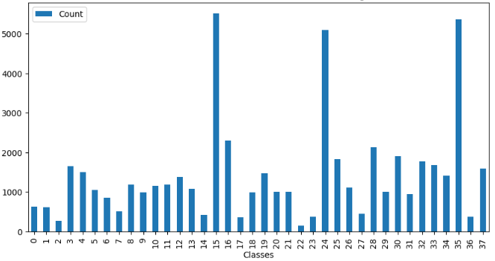

**Fig 1**. Imbalanced distribution of the counts of images.

Figure 2 shows sample images of plant diseases for 38 classes that appear in the PlantVillage public dataset.

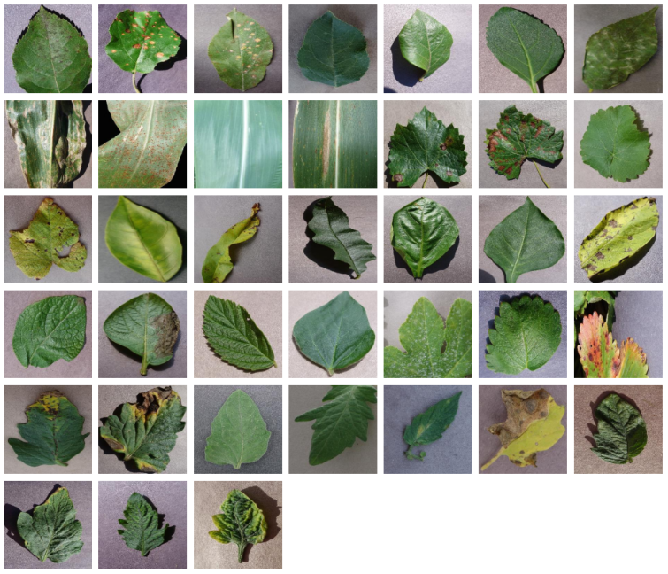

**Fig 2**. Sample images of plant diseases on the PlantVillage dataset.

The second FGVC8 dataset is provided by the Kaggle Phytopathology 2021-FGVC8 Challenge, which has a total of 18,632 plant disease images belonging to 12 categories, all 4000 × 2672 pixels in size. This dataset reflects real field scenarios by representing non-homogeneous backgrounds of leaf images taken at different maturity stages and at different times of day under different focal camera settings. Figures 3 and 4 show the imbalance distribution map of the FGVC8 public dataset and sample images of plant diseases for 12 classes, respectively.

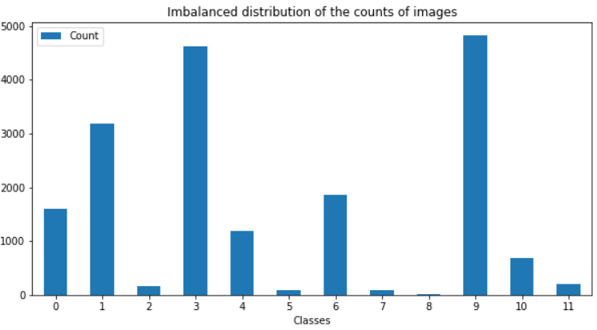

**Fig 3**. Imbalanced distribution of the counts of images.

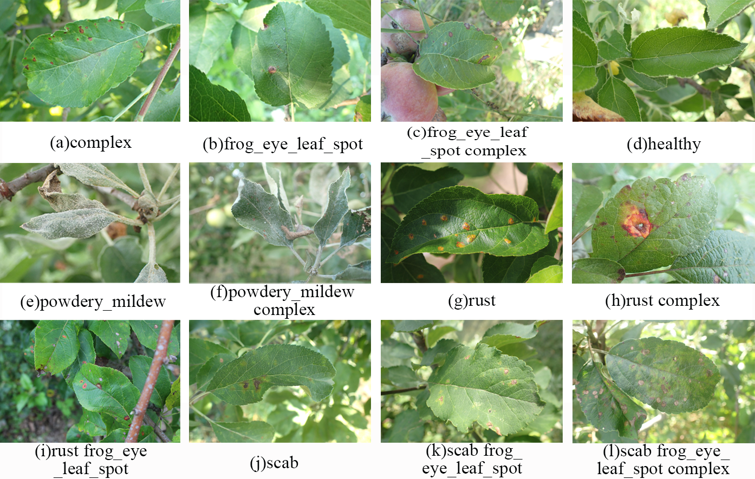

**Fig 4**. Sample images of plant diseases on the FGVC8 dataset.

## *2.2. Image preprocessing and sample augmentation technique*

Firstly, we rescale all the images in the two datasets to 256×256 pixels using the resize method in the transforms module of the torchvision package. Then we divide them into training set and validation set according to the ratio of 8:2. After that, we adopt online data enhancement way and use RandomHorizontalFlip, RandomVerticalFlip, RandAugment[30] and ColorJitter methods in the transforms module of the torchvision package to perform fast data enhancement operations on data images. By enhancing the image data for the training set, it expands the scale of the data set, increases the diversity of data samples, reduces the risk of model overfitting, and improves the generalization ability and robustness of the model. Figure 5 shows examples of original images and corresponding data enhanced images.

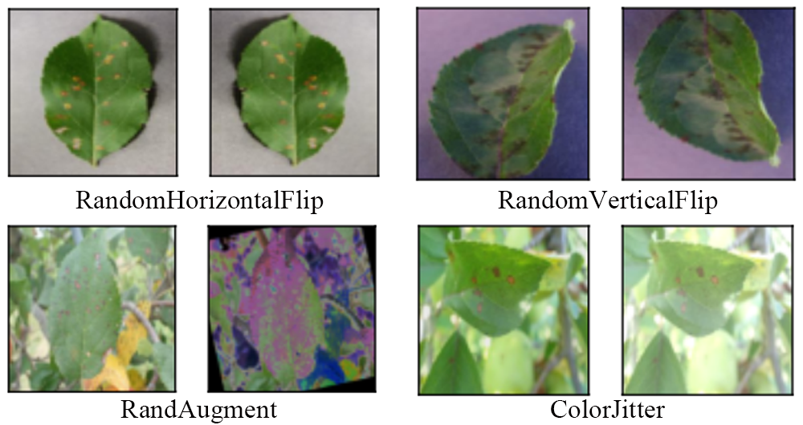

**Fig 5**. Examples of original images and corresponding data enhanced images.

## *2.3. Optimization method and loss function*

For this research, we use the AdamW[31] optimization algorithm, which is based on Adam with the addition of the L2 regular term to solve some problems of Adam by weights decays. The advantages of the AdamW optimization algorithm are: firstly, through adding the L2 regular term, the size of the weights can be better controlled while maintaining the stability of the gradient; secondly, the risk of overfitting can be effectively reduced, thus improving the generalization ability of the model; and finally, it has a better performance when dealing with large-scale data sets.

The main goal of the optimization algorithm is to update the weights at each stage in order to achieve the effect of optimizing the model. The learning rate is one of the important hyperparameters for training neural networks. When the learning rate is too large, the model will be difficult to converge, and when it is too small, the convergence rate will be too slow, so a reasonable learning rate is necessary for the model to converge to the minimum point instead of the local optimum point or saddle point.

The loss function is commonly used to measure the goodness of a model, that is, to express the degree of gap between the predicted and actual values. When dealing with classification problems, the cross-entropy loss function is usually used to assess the difference between the estimated and actual values. The cross-entropy loss function portrays the distance between two probability distributions, and the smaller the value of the cross-entropy loss, the better the model prediction. The cross-entropy loss function *L* is defined in Equation (1) where ***y*** and $\hat{y}$ are observed labels and estimated labels respectively, ***o*** are the outputs of the neural networks that are often called logits.

$L\left(y,\hat{y}\right)=-\sum_{i=1}^{n}{y_{i}\text{log}\frac{\text{exp(}o_{i}\text{)}}{\sum_{j=1}^{n}{\text{exp(}o_{j})}}}$ (1)

## *2.4. FoldNet model*

The main objective of this study is to design a high-performance, highly robust lightweight deeply isotropic neural network model so that it can explore deeper layers for more accurate identification and classification of plant diseases. We will specifically describe the FoldNet network model in three parts.

### 2.4.1. Mapping residual neural network architectures to directed acyclic graphs

We evaluate the influence of structural features of the neural network on the network performance by mapping the architecture of the residual neural network to a directed acyclic graph with a simple mapping rule. As shown in Figure 6, the nodes in the graph represent nonlinear transitions between data, and the edges in the graph represent data flow. According to such mapping rule, the structure of the residual network is mapped as a complete directed acyclic graph. Since all the weights of the neural network are mapped to the nodes of the graph, and all the connection structures are mapped to the edges of the graph, such mapping also separates the effects of the network structure and the nonlinear transformations on the performance, separately. Figure 6a shows a residual neural network structure in which all the dashed lines of the jump connections form a direct path. This direct path allows the forward activation and the reverse gradient to flow straight through the constant function without loss of information, and then the model can be improved more consistently by increasing the depth as well as avoiding the gradient disappearance problem. In summary, this structure greatly improves the performance of the model.



**Fig 6**. Three examples of mapping from neural networks to directed acyclic graphs. **(a)** Traditional residual neural network FoldNet_1. **(d)** Fully directed acyclic graph mapped by FoldNet_1. **(b)** Improved folded residual neural network FoldNet_2. **(e)** Fully directed acyclic graph mapped by FoldNet_2. **(c)** Improved folded residual neural network FoldNet_3. **(f)** Fully directed acyclic graph mapped by FoldNet_3. Where all Fi nodes in Figures 6a, 6b, and 6c represent nonlinear transformations between data, and all internal circles with plus signs represent the sum of all input data. In Figures. 6d, 6e, 6f all nodes consist of summation and nonlinear transformation, lines indicate the data flow between nodes.

### 2.4.2. Improving the incoherence of DAGs by folding residual networks

Since in traditional residual neural networks, all jump connections are restricted to adjacent layers and the distance between any two layers is always equal to 1, which limits the representational power of the network. Therefore, we fold the residual neural network backbone chain back and forward into an accordion-like structure, as shown in Figures. 6b and 6c.

The improved accordion-like structure is superior to the chain-like structure of the traditional residual neural network, first of all, the number of direct paths is increased from one to several, secondly, the distance between layers connected through jump connections is different, both are determined by the "folding length", we named such a folding neural network as FoldNet-d, where d is the "folding length". In FoldNet-d networks, d represents the number of direct paths, and the distance of jump connections is an integer in the set [2,4, . . . ,2(d-1)], but when d=1, the model simplifies to a traditional residual neural network. Figures 6a, 6b, and 6c describe the network architectures of FoldNet-1, FoldNet-2, and FoldNet-3, respectively, while Figures 6d, 6e, and 6f describe the fully directed acyclic graphs mapped by FoldNet-1, FoldNet-2, and FoldNet-3, respectively.

For the directed acyclic graph given by the n × n adjacency matrix A, where element $a_{ij}=1$ if there is a directed edge from node i to node j , and element $a_{ij}=0$ if there is not. The incoming and outgoing degrees of node i are $k_{i}^{in}=\sum_{j}{a_{ji}}$ and $k_{i}^{out}=\sum_{j}{a_{ij}}$, respectively. The first node (i = 1) can never have inward edges, so $k_{1}^{in}=0$. Analogously, the last node (i = n) can never have outward edges, so ${ k}_{n}^{out}=0$. The trophic level si of node i is defined by Equation (2).

$s_{i}=1+\frac{1}{k_{i}^{in}}\sum_{j}{a_{ji}s_{j}}$, (2)

We used the trophic distance: $x_{ij}=s_{i}-s_{j}$ to represent each edge of the directed acyclic graph, and then studied the distribution of trophic distances p(x) on the network. The homogeneity of p(x) is generally referred to as trophic coherence: the closer the trophic distances of all edges, the higher the coherence of the network. The degree of coherence is usually measured using the standard deviation of p(x), which is named as the incoherence parameter: $q=\sqrt{x^{2}-1}$. We map the architecture of the neural network onto a directed acyclic graph, and use the incoherence parameter q to measure the degree of order of the directed acyclic graph.

According to the main figure in Figure 7, we find that the incoherence parameter q increases along with the number of nodes (layers of the neural network) and the fold length d in the directed acyclic graph. The inset in Figure 7 shows the cumulative distribution function (CDF) of path lengths in the directed acyclic graph when the number of nodes is equal to 50, where the proportion of shorter paths grows as the fold length d increases.

By comparing the incoherence and path length of the FoldNet-d neural network with d ∈ [2,3,4] and the conventional residual neural network at d = 1, we concluded that the disorder of the folded residual network FoldNet-d is higher and the shorter paths account for a larger proportion, thus improving the performance of the FoldNet-d network.

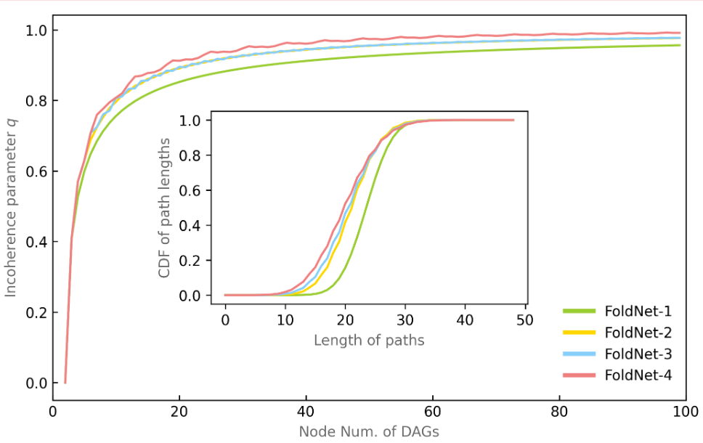

**Fig 7.** Incoherence and path length of DAG. The main figure demonstrates the relationship between the incoherence parameter q and the number of DAG nodes and the folding length d. The inset figure illustrates the relationship between the path length and the folding length d.

### 2.4.3. Model architecture

Isotropic CNNs emerged partially inspired by the state-of-the-art attention-based transformer architectures in computer vision that are isotropic architectures. Compared to pyramidical architectures, recent research discovers that isotropic architectures may improve performance or even meet state-of-the-art performance with a lot lighter layers. Therefore, this study designs a lightweight deeply isotropic neural network model, FoldNet, which has the same size and shape for all layers throughout the network. In this network model architecture, images are first segmented into a series of patches, and then these patches are passed to a repeating block chain, which is eventually used for automatic identification and classification of plant disease images. Compared to traditional residual neural networks with only one direct path, FoldNet has multiple direct paths throughout the network, therefore the model can explore deeper into the network and thereby identify plant pest and disease characteristics more accurately.

The FoldNet model architecture is shown in Figure 8a, which consists of a Patch embedding layer, repeatedly applied folding blocks, a global average pooling layer, and a classifier block. In which, in the patch embedding layer, the size of patch p, the hidden dimension h, which can implement the convolution operation with the input channel $C_{in}$, the output channel h, the kernel size p and the step size p. Each folding block contains d-1 nonlinear transformations Fi, as shown by the red dashed rounded rectangles in Figure 8a. Each nonlinear transform Fi itself consists of a deep convolution and a point convolution, each followed with a GELU activation function and a batch normalization layer, as illustrated in Figure 8b. The depth convolution is a grouped convolution with k×k convolution kernels and the group is equal to the number of channels h. The point convolution is a convolution with 1×1 convolution kernels. Finally, we use global average pooling to obtain the feature vector, which is passed to a linear classifier and a softmax function to predict the probability of all classes.



**Fig 8.** (a)The model architecture of FoldNet, which starts with a patch embedding layer, followed by a series of folded blocks shown by red dashed rectangles, then a pooling layer and a linear classifier, and finally a prediction class. where the depth n=6, the folding length d=3, and the number of folding blocks is equal to n / (d-1) = 3. (b) Specific details of each nonlinear transform Fi, including a deep convolution and a point convolution, each followed by an activation function and a BatchNorm layer.

3. Experimental results and analysis

3.1. Experimental configuration and hyperparameter setting

In this experiment, FoldNet model was implemented using Python programming language, PyTorch deep learning framework, and FoldNet model was evaluated using PyTorch Lightning library. In addition, due to the limited experimental conditions, we used both the online server Kaggle and PaperSpace to provide GPUs for training and evaluation of the models. Kaggle Kernels offers T4×2 GPUs that allow for each user 30 hours of free access per week, with a limit of 9 hours per run. PaperSpace offers a more powerful and faster paid A4000 GPU, but it has a maximum run time limit of 6 hours per run. The software and hardware configurations are shown in Table 2.

**Table 2**. software and hardware environment.

|  |  |  |
| --- | --- | --- |
| **Name** | **PaperSpace** | **Kaggle** |
| CPU | 8cores | 2cores |
| GPU | A-4000 | T4×2 |
| RAM | 45GB | 13GB |
| CUDA | 11.6 | 11.4 |
| Python | 3.9 | 3.7.12 |
| Pytorch | 1.12 | 1.13 |
| Pytorch_lightning | 1.8.0 | 1.9.4 |

The deep isotropic neural network model FoldNet is macroscopically designed by changing the connectivity method of skip connections between the layers in the residual neural network; therefore, we will focus on the depth *n* and the fold length *d* of the model, which reflect macro structural features of the model. At the meantime, we keep the optimized values of the hidden dimension *h*, the patch size *p* and the kernel size *k*. These parameters, in turn, reflect micro design features of the model. According to the suggestion in the ConvMixer[32] model, we set the hidden dimension h=128, the patch size p=8, and the kernel size k=5.

The FoldNet model has slightly different parameter settings on different data sets. For the PlantVillage dataset, we train FoldNet for 100 epochs with a batch size of 128, using the AdamW optimizer with a learning rate of 1e-2 and a weight decay of 0.1. There is a linear warm-up of 10 epochs with an initial learning rate of 1e-5, followed by a cosine decay schedule. For the FGVC8 dataset, FoldNet is also trained for 100 epochs with a batch size of 64, using the AdamW optimizer with a learning rate of 1e-2 and a weight decay of 0.05, where there is a linear warm-up of 10 epochs with an initial learning rate of 1e-5, followed by a cosine decay schedule.

3.2. Evaluation metrics

In the experiments, we used accuracy, precision, recall and F1 score as evaluation metrics to make a comprehensive assessment of model performance. We usually use the following metrics to obtain evaluation results: If an instance is a positive class and is predicted to be a positive class, it is a true class TP (True Positive); If an instance is a positive class but is predicted to be a negative class, it is a false negative class FN (False Negative); If an instance is a negative class but is predicted to be a positive class, it is a false positive class FP (False Positive); If an instance is a negative class and is predicted to be a negative class, it is a True Negative class TN (True Negative). Where T/F represents the correctness or incorrectness of the prediction, and P/N represents the positive or negative case of the prediction result. The accuracy rate is the proportion of correctly predicted samples to the total samples, which can reflect the overall performance of the model and is often expressed in equation (3). The precision rate is the proportion of samples predicted to be positive and actually positive to those predicted to be positive, and is often expressed in equation (4). Recall is the proportion of positive predicted and actual positive samples to the actual positive samples, and is often expressed in equation (5). In order to obtain a balance between precision and recall, the F1-score metric is used, which is the summed average of precision and recall, and this score considers both false positives and false negatives; moreover, a higher F1-score indicates better model performance, which is often expressed in equation (6).

$Accuracy=\frac{TP+TN}{TP+TN+FP+FN}$ (3)

$Precision=\frac{TP}{TP+FP}$ (4)

$Recall=\frac{TP}{TP+FN}$ (5)

$F1score=\frac{2precision*recall}{precision+recall}$ (6)

3.3. Performance of the experiments

3.3.1.Comparison of experimental results with different hyperparameter values

**Table 3.** Validation accuracy and validation loss of FoldNet-d for the PlantVillage dataset with hidden dimension *h* = 64 and *h* = 128. The depth *n* is equal to the number of folding blocks times *d* − 1. The patch size *p* and kernel size *k* are fixed as *p* = 8 and *k* = 5.

|  |  |  |  |  |  |  |
| --- | --- | --- | --- | --- | --- | --- |
| **Model** | **Num.of Folding Blocks** | **Corresponding Depth n** | **h=64** | **h=128** | **h=64** | **h=128** |
| Val.Accuracy | | Val.Loss | |
| FoldNet-1 | 16 | 16 | 0.9960 | 0.9974 | 0.0114 | 0.0092 |
| 24 | 24 | 0.9959 | 0.9976 | 0.0128 | 0.0085 |
| 32 | 32 | 0.9958 | 0.9974 | 0.0144 | 0.0127 |
| 40 | 40 | 0.9962 | 0.9968 | 0.0142 | 0.0105 |
| 48 | 48 | 0.9960 | 0.9976 | 0.0171 | 0.0110 |
| FoldNet-2 | 16 | 16 | 0.9961 | 0.9976 | 0.0162 | 0.0071 |
| 24 | 24 | 0.9961 | 0.9980 | 0.0150 | 0.0062 |
| **32** | **32** | 0.9974 | **0.9984** | 0.0100 | **0.0039** |
| 40 | 40 | 0.9975 | 0.9977 | 0.0094 | 0.0078 |
| 48 | 48 | 0.9975 | 0.9983 | 0.0101 | 0.0084 |
| FoldNet-3 | 8 | 16 | 0.9971 | 0.9978 | 0.0115 | 0.0105 |
| 9 | 18 | 0.9970 | 0.9981 | 0.0115 | 0.0097 |
| 12 | 24 | 0.9976 | 0.9983 | 0.0102 | 0.0053 |
| 13 | 26 | 0.9967 | 0.9982 | 0.0128 | 0.0075 |
| 16 | 32 | 0.9964 | 0.9981 | 0.0128 | 0.0097 |
| 17 | 34 | 0.9968 | 0.9981 | 0.0118 | 0.0087 |
| 24 | 48 | 0.9972 | 0.9979 | 0.0109 | 0.0072 |
| FoldNet-4 | 5 | 15 | 0.9966 | 0.9982 | 0.0125 | 0.0066 |
| 7 | 21 | 0.9969 | 0.9980 | 0.0106 | 0.0077 |
| 9 | 27 | 0.9970 | 0.9981 | 0.0099 | 0.0075 |
| 11 | 33 | 0.9971 | 0.9980 | 0.0148 | 0.0081 |
| 13 | 39 | 0.9973 | 0.9981 | 0.0131 | 0.0063 |
| 15 | 45 | 0.9972 | 0.9981 | 0.0141 | 0.0094 |
| 16 | 48 | 0.9975 | 0.9983 | 0.0119 | 0.0088 |

Since the effect of depth *n* and fold length *d* on the performance of the FoldNet model is orthogonal to the hidden dimension *h*, we conducted experiments for hidden dimension *h* = 64 and *h* = 128, respectively, to compare the performance of the model for plant disease recognition under different hyperparameters.

For the PlantVillage dataset, the experimental results of the FoldNet model under this dataset are shown in Table 3, with a total of 24 items. Through experiments our model obtains optimal results at epoch=98 when the hidden dimension h=128. In detail, our model achieves the best validation accuracy of 0.9984 and the lowest validation loss of 0.0039 on the PlantVillage validation set, while the number of model parameters is only 685k, which proves the effectiveness and robustness of the proposed model. As shown in Table 3, from an overall perspective, FoldNet_2, FoldNet_3, and FoldNet_4 with d>1 outperform FoldNet_1 with d=1 on the PlantVillage dataset. In addition, when the hidden dimension h = 128, the validation accuracy of all FoldNet models at the corresponding depth *n* is higher than that at the hidden dimension h = 64, and the validation loss of all FoldNet models at the corresponding depth *n* is lower than that at the hidden dimension h = 64. Moreover, FoldNet_2 with d>1 obtains the highest validation accuracy at depth n=32 when the hidden dimension h=128. Compared with foldNet_1 with h=128, FoldNet_2 improves the validation accuracy by 0.1% at the same depth n=32 and its validation loss is reduced by 0.88%. Compared with foldNet_2 with h=64, FoldNet_2 with h=128 improves the validation accuracy by 0.1% and its validation loss is reduced by 0.61% at the same depth n=32.

**Table 4.** Validation accuracy and validation loss of FoldNet-d for the FGVC8 dataset with hidden dimension *h* = 64 and *h* = 128. The depth *n* is equal to the number of folding blocks times d − 1. The patch size *p* and kernel size *k* are fixed as *p* = 8 and *k* = 5

|  |  |  |  |  |  |  |  |  |  |
| --- | --- | --- | --- | --- | --- | --- | --- | --- | --- |
| **Model** | **Num.of Folding Blocks** | **Corresponding**  **Depth n** | **h=64** | **h=128** | | | **h=64** | | **h=128** |
| **Val.Accuracy** | | | | | **Val.Loss** | |
| FoldNet-1 | 16 | 16 | 0.8714 | | 0.8792 | 0.4151 | | | 0.3947 |
| 24 | 24 | 0.8703 | | 0.8797 | 0.4027 | | | 0.4002 |
| 32 | 32 | 0.8696 | | 0.8730 | 0.4076 | | | 0.3982 |
| 40 | 40 | 0.8669 | | 0.8792 | 0.4200 | | | 0.4186 |
| 48 | 48 | 0.8687 | | 0.8790 | 0.4022 | | | 0.3929 |
| FoldNet-2 | 16 | 16 | 0.8804 | | 0.8866 | 0.3857 | | | 0.3733 |
| **24** | **24** | 0.8757 | | **0.9049** | 0.4079 | | | **0.3789** |
| 32 | 32 | 0.8787 | | 0.8879 | 0.4182 | | | 0.3959 |
| 40 | 40 | 0.8714 | | 0.8870 | 0.4080 | | | 0.4065 |
| 48 | 48 | 0.8719 | | 0.8846 | 0.4082 | | | 0.4065 |
| FoldNet-3 | 8 | 16 | 0.8681 | | 0.8910 | 0.4053 | | | 0.3981 |
| 9 | 18 | 0.8828 | | 0.8836 | 0.3879 | | | 0.3850 |
| 12 | 24 | 0.8706 | | 0.8807 | 0.4079 | | | 0.3957 |
| **13** | **26** | 0.8787 | | 0.8801 | 0.4031 | | | 0.3995 |
| 16 | 32 | 0.8736 | | 0.8900 | 0.4105 | | | 0.3857 |
| 17 | 34 | 0.8810 | | 0.8834 | 0.4023 | | | 0.3987 |
| 24 | 48 | 0.8745 | | 0.8801 | 0.4143 | | | 0.4009 |
| FoldNet-4 | 5 | 15 | 0.8774 | | 0.8856 | 0.3945 | | | 0.3850 |
| 7 | 21 | 0.8774 | | 0.8887 | 0.4332 | | | 0.3868 |
| 9 | 27 | 0.8792 | | 0.8821 | 0.4113 | | | 0.4084 |
| 11 | 33 | 0.8743 | | 0.8875 | 0.4012 | | | 0.3700 |
| 13 | 39 | 0.8768 | | 0.8822 | 0.4050 | | | 0.4011 |
| 15 | 45 | 0.8836 | | 0.8950 | 0.3958 | | | 0.3946 |
| 16 | 48 | 0.8793 | | 0.8880 | 0.4003 | | | 0.3968 |

For the realistic scene dataset FGVC8, the experimental results of the FoldNet model under this dataset are shown in Table 4, with a total of 24 items. Through experiments our model obtains optimal results at epoch=81 when the hidden dimension h=128. In detail, our model achieves the highest validation accuracy of 0.9049 and low validation loss of 0.3789 on the validation set of FGVC8, while the number of model parameters is only 516k, which again demonstrates the effectiveness and robustness of the proposed model. As shown in Table 4, from an overall perspective, FoldNet_2, FoldNet_3, and FoldNet_4 with d>1 outperform FoldNet_1 with d=1 on the PlantVillage dataset. In addition, when the hidden dimension h = 128, the validation accuracy of all FoldNet models at the corresponding depth n is higher than that at the hidden dimension h = 64, and the validation loss of all FoldNet models at the corresponding depth n is lower than that at the hidden dimension h = 64. In addition, when the hidden dimension h=128, FoldNet_2 with d>1 obtains the highest validation accuracy at depth n=24. Compared with foldNet_1 with h=128, FoldNet_2 improves the validation accuracy by 2.52% at the same depth n=24 and its validation loss is reduced by 2.13%. Compared with foldNet_2 with h=64, FoldNet_2 with h=128 improves the validation accuracy by 2.92% and its validation loss is reduced by 2.9% at the same depth n=24.

3.3.2. Evaluation of the proposed method

To validate the success of the FoldNet network model for plant disease classification, we used confusion matrices to evaluate the classification performance of the model. The confusion matrix is a visualization tool in machine learning, which itself is a table layout that compares the predicted class labels with the actual class labels for all data instances. The rows of the matrix represent the actual classes, while the columns represent the predicted classes. By analyzing the confusion matrix, we can determine how well the model is able to distinguish between different classes, as well as which classes are most often confused with one another. Popular performance metrics, such as accuracy, precision, recall, F-1 score could be derived from the confusion matrix.

**Table 5.** Performance evaluation on the PlantVillage for each class.

|  |  |  |  |  |  |
| --- | --- | --- | --- | --- | --- |
| **Plant** | **Disease** | **Class labels** | **Precision** | **Recall** | **F1-score** |
| Apple | Healthy | 0 | 1.00 | 1.00 | 1.00 |
| Scab | 1 | 1.00 | 1.00 | 1.00 |
| Black Rot | 2 | 1.00 | 1.00 | 1.00 |
| Cedar Rust | 3 | 1.00 | 1.00 | 1.00 |
| Blueberry | Healthy | 4 | 1.00 | 1.00 | 1.00 |
| Cherry | Healthy | 5 | 1.00 | 0.9883 | 0.9941 |
| Powdery Mildew | 6 | 1.00 | 1.00 | 1.00 |
| corn | Healthy | 7 | 1.00 | 1.00 | 1.00 |
| Cercospora Leaf Spot | 8 | 0.9736 | 0.9910 | 0.9823 |
| Common Rust | 9 | 1.00 | 0.9956 | 0.9978 |
| Northern Leaf Blight | 10 | 0.9951 | 0.9903 | 0.9927 |
| Grape | Healthy | 11 | 1.00 | 1.00 | 1.00 |
| Black Rot | 12 | 1.00 | 1.00 | 1.00 |
| Black Measles | 13 | 1.00 | 1.00 | 1.00 |
| Isariopsis Leaf Spot | 14 | 1.00 | 1.00 | 1.00 |
| Orange | Citrus Greening | 15 | 1.00 | 0.9990 | 0.9995 |
| Peach | Healthy | 16 | 1.00 | 1.00 | 1.00 |
| Bacterial Spot | 17 | 1.00 | 1.00 | 1.00 |
| BellPepper | Healthy | 18 | 1.00 | 1.00 | 1.00 |
| Bacterial Spot | 19 | 0.9952 | 1.00 | 0.9976 |
| Potato | Healthy | 20 | 1.00 | 1.00 | 1.00 |
| Early Blight | 21 | 1.00 | 1.00 | 1.00 |
| Late Blight | 22 | 1.00 | 1.00 | 1.00 |
| Raspberry | Healthy | 23 | 1.00 | 1.00 | 1.00 |
| Soybean | Healthy | 24 | 0.9989 | 1.00 | 0.9994 |
| Squash | Powdery Mildew | 25 | 0.9971 | 1.00 | 0.9985 |
| Strawberry | Healthy | 26 | 1.00 | 1.00 | 1.00 |
| Leaf Scorch | 27 | 0.9949 | 1.00 | 0.9974 |
| Tomato | Healthy | 28 | 0.9965 | 1.00 | 0.9982 |
| Bacterial Spot | 29 | 0.9951 | 1.00 | 0.9975 |
| Early Blight | 30 | 0.9951 | 0.9857 | 0.9904 |
| Late Blight | 31 | 0.9951 | 0.9927 | 0.9939 |
| Leaf Mold | 32 | 1.00 | 1.00 | 1.00 |
| Septoria Leaf Spot | 33 | 0.9972 | 1.00 | 0.9986 |
| Spider Mites | 34 | 0.9936 | 1.00 | 0.9968 |
| Target Spot | 35 | 1.00 | 0.9966 | 0.9983 |
| Yellow Leaf Curl | 36 | 1.00 | 0.9972 | 0.9986 |
| Mosaic Virus | 37 | 1.00 | 1.00 | 1.00 |
|  | Micro-average |  | 0.9984 | 0.9984 | 0.9984 |

The PlantVillage dataset has a tree-like hierarchical structure with three levels. The root node is the overall category, plant. The first level is the 14 specific plant species. The second level is the healthy or disease status of the plant. Thus, we used a hierarchical confusion matrix to evaluate the model on the 10861 validation images in the PlantVillage dataset. The precision, recall, and F1 scores for each category in the PlantVillage dataset are shown in Table 5. The micro-averages of precision, recall and F1 scores are 0.9986, 0.9986 and 0.9986. For the FGVC8 apple leaf disease dataset, we still chose the hierarchical confusion matrix to evaluate the model for the 3727 validation images in the FGVC8 dataset. The precision, recall and F1 scores for each category in the FGVC8 dataset are shown in Table 6. The micro-averages of precision, recall, and F1 score were 0.9050, 0.9050, and 0.9050. Finally, Figures 9 and 12 show the confusion matrix plots corresponding to the PlantVillage and FGVC8 datasets.

**Table 6.** Performance evaluation on the FGVC8 for each class.

|  |  |  |  |  |  |  |
| --- | --- | --- | --- | --- | --- | --- |
| **Plant** | | **Disease** | **Class labels** | **Precision** | **Recall** | **F1-score** |
| Apple | Complex | | 0 | 0.7071 | 0.7376 | 0.7220 |
| Frog eye leaf spot | | 1 | 0.9007 | 0.9696 | 0.9339 |
| Frog eye leaf spot complex | | 2 | 0.6666 | 0.3636 | 0.4705 |
| Healthy | | 3 | 0.9572 | 0.9828 | 0.9698 |
| Powdery mildew | | 4 | 0.9288 | 0.9406 | 0.9347 |
| Powdery mildew complex | | 5 | 0.75 | 0.625 | 0.6818 |
| Rust | | 6 | 0.8968 | 0.9630 | 0.9287 |
| Rust complex | | 7 | 1. | 0.6470 | 0.7857 |
| Rust frog eye leaf spot | | 8 | 0.7222 | 0.5 | 0.5909 |
| Scab | | 9 | 0.9563 | 0.9457 | 0.9509 |
| Scab frog eye leaf spot | | 10 | 0.6125 | 0.4117 | 0.4924 |
| Scab frog eye leaf spot complex | | 11 | 0.8571 | 0.15 | 0.2553 |
| Micro-average | | | 0.9050 | 0.9050 | 0.9050 |

On the PlantVillage dataset, the FoldNet model achieves 99.84% accuracy, and as observed from the confusion matrix shown in Figure 9, the proposed FoldNet method has fewer false positives and false negatives on the PlantVillage dataset, and only 17 images in this dataset are misclassified. After quantitatively analyzing these 17 images, we find three interesting points need to be noted: First, compared to incorrect classification within the same species, incorrect classification across species is very rare. Only 5 images are incorrectly identified as images of different plant species, as shown in Figure 10, while the other 12 images are identified correctly as to their species, as shown in Figure 11, even though incorrectly as to their disease status. This reflects the robustness of the FoldNet model, which can correctly predict the species of an image even if its prediction of the image's disease status is wrong. Second, the 12 images that are incorrectly classified within the same species belong to two species, corn and tomato, rather than uniformly distributed in all the 14 species. 4 of the 12 images belong to corn, and the other 8 images belong to tomato. This reflects the complexity of the images of corn and tomato. Third, in the 17 images that are classified incorrectly, several images are wrong in ground truth or captured in an extreme situation. For example, the first 'Cherry Healthy' image is actually field background; two "Tomato Late Blight" images have a very small foreground and a very large background.

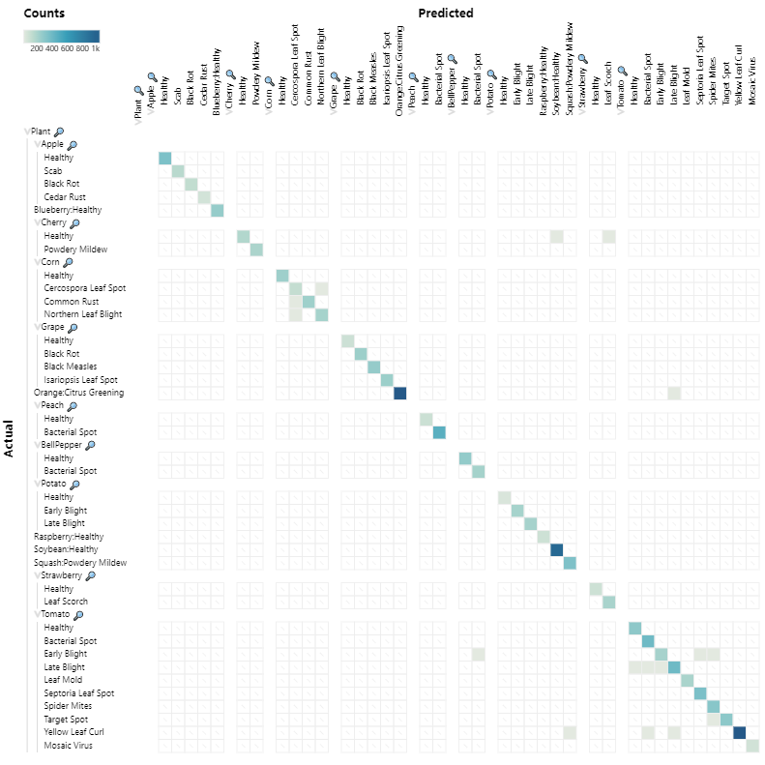

**Fig 9.** Confusion matrix of FoldNet for the PlantVillage.

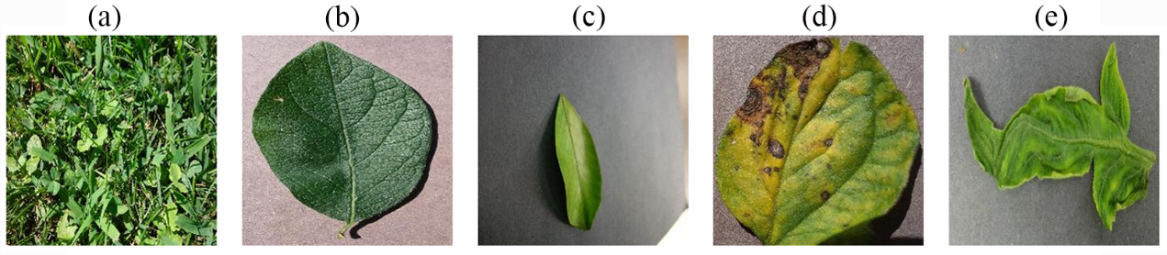

**Fig 10.** the 5 images that are incorrectly predicted as images of other plant species. (a) Actual: Cherry Healthy, Predicted: Soybean Healthy;(b)Actual : Cherry Healthy, Predicted: Strawberry Leaf Scorch;(c) Actual : Orange Citrus Greening, Predicted: Tomato Late Blight;(d)Actual: Tomato Early Blight, Predicted: BellPepper Bacterial Spot; (e)Actual: Tomato Yellow Leaf Curl, Predicted: Squash Powdery Mildew.

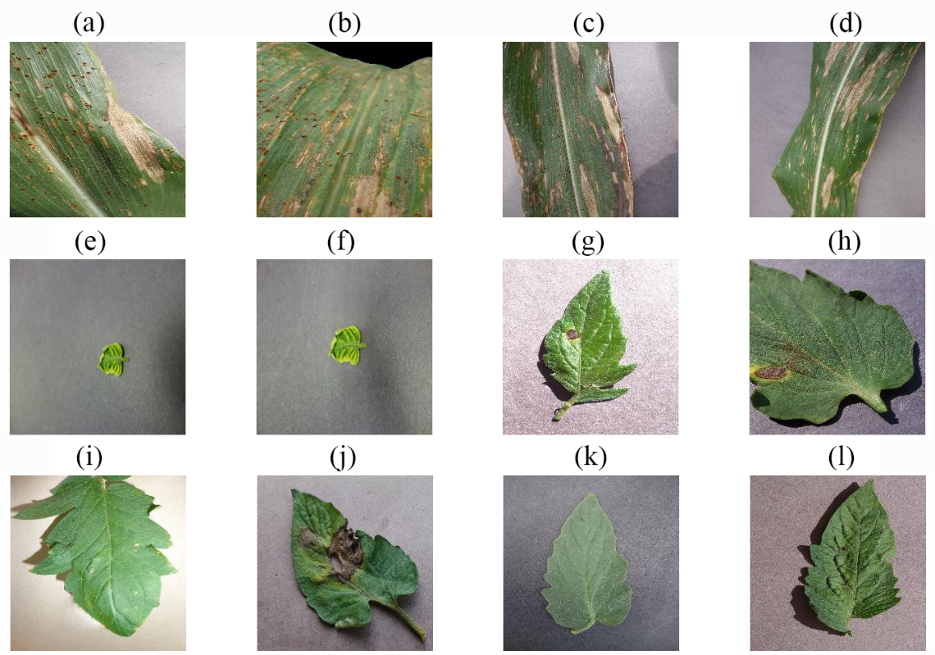

**Fig 11.** the 12 images that correctly predicted species, but incorrectly predicted disease state.(a) Actual : Corn Cercospora Leaf Spot, Predicted: Corn Northern Leaf Blight.(b)Actual : Corn Common Rust, Predicted: Corn Cercospora Leaf Spot.(c)Actual : Corn Northern Leaf Blight, Predicted: Corn Cercospora Leaf Spot.(d)Actual : Corn Northern Leaf Blight, Predicted: Corn Cercospora Leaf Spot;(e)Actual : Tomato Yellow Leaf Curl, Predicted: Tomato Late Blight; (f)Actual : Tomato Yellow Leaf Curl, Predicted: Tomato Bacterial Spot;(g)Actual : Tomato Early Blight, Predicted: Tomato Spider Mites;(h)Actual : Tomato Early Blight, Predicted: Tomato Septoria Leaf Spot; (i) Actual : Tomato Late Blight, Predicted: Tomato Bacterial Spot;(j)Actual :Tomato Late Blight, Predicted: Tomato Early Blight;(k)Actual : Tomato Late Blight, Predicted: Tomato Healthy;(l) Actual : Tomato Target Spot, Predicted: Tomato Spider Mites.

On the FGVC8 dataset, the FoldNet model achieved an accuracy of 90.49%. From the observation of the confusion matrix shown in Figure 12, we can obviously see that the proposed FoldNet method has good overall classification performance for the 12 classes in this dataset, but there are still some misclassified samples. Through comparative analysis, firstly, we found that most of the misclassified samples were exhibiting similar epigenetic characteristics, and secondly, there were multiple different types of diseases in the complex class of leaf diseases, and these diseases were difficult to distinguish from those in other classes because of their similarity. Figure 13 shows some of the misclassified samples.

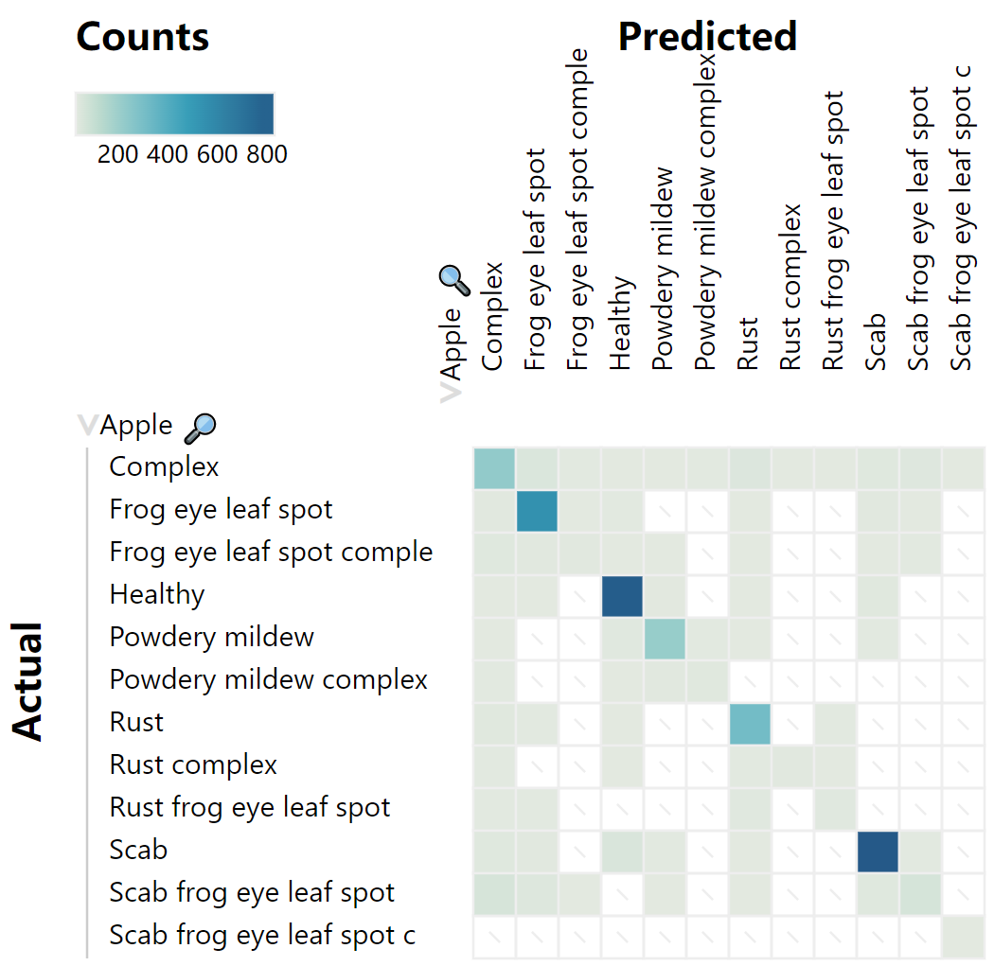

**Fig 12.** Confusion matrix of FoldNet for the FGVC8.

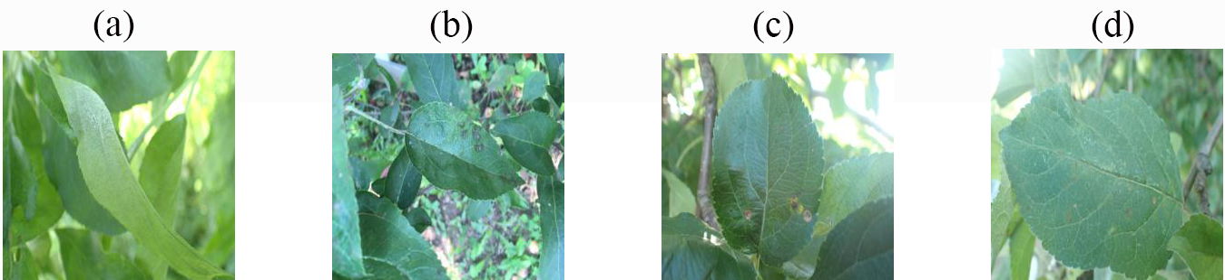

**Fig 13.** 4 example graphs of incorrectly predicted disease states. (a) Actual: Powdery mildew, Predicted: Healthy; (b)Actual: Rust , Predicted: Healthy; (c)Actual: Rust frog eye leaf spot, Predicted: Complex; (d)Actual: Scab frog eye leaf spot complex , Predicted: Scab.

3.3.3. Qualitative Analysis

GradCAM heat map is a visualization tool to explain the decision process of a deep learning model. Through GradCAM heat maps, we can analyze the features of the regions that the model focuses on when classifying the input data. We randomly selected three disease samples from each of the PlantVillage and FGVC8 validation datasets, and then visualized the plant disease identification results using class activation maps (CAM), where red highlighted areas indicate areas where the model focuses strongly on one category, while blue indicates areas where the model discriminates more strongly between other categories. Figure 14 shows the original map of different plant diseases and the map of plant disease features captured by the proposed method, respectively. After comparison, it is found that the method can clearly discover the location of plant disease regions and gradually enhance the characterization of disease features in the region of interest. In addition, we found that the method is good at capturing plant disease areas and extracting subtle features for both laboratory data and realistic scenarios, thus improving the accurate identification of plant diseases.

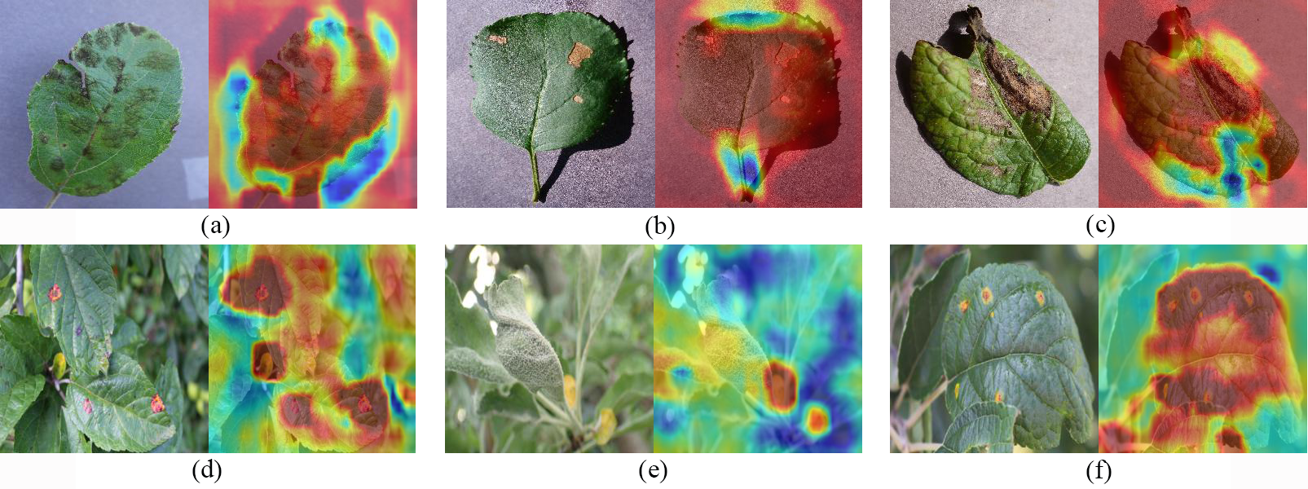

**Fig 14.** Feature map of different crop diseases. (a) Apple scab. (b) Black rot. (c) Potato Late blight. (d)Apple rust. (e)powdery mildew. (f) Apple rust.

### 3.3.4. Comparison experiments on different methods

In this section we design an experiment to compare the performance of the proposed method with other methods for disease identification, where all methods will be performed on PlantVillage and FGVC8 datasets.

**Table 7.** Comparative analysis of the proposed method with other methods on PlantVillage regarding computational complexity

|  |  |  |
| --- | --- | --- |
| **Model** | **parameter** | **Processing time** |
| VGG16[33] | 119.6M | 1051ms |
| ResNet50(Transfer learning)[34] | 23.6M | 1583ms |
| ResNet101 | 42.5M | 2766ms |
| ResNet152 | 58.5M | 4366ms |
| DenseNet201[35] | 20M | 2573ms |
| Inception V4[36] | 41.2M | 4042ms |
| EfficientNet[37] | 19.4M | 1548ms |
| EfficientNetV2[38] | 15.2M | 1125ms |
| DenseNet121(Transfer learning)[15] | 7.1M | 2165ms |
| modified EfficientNetV2[21] | 14.4M | 1053ms |
| **Proposed** | **685k** | **1010ms** |

In Tables 7 and Tables 8 we show the complexity of the model, from which we can obviously see that our proposed method always contains a minimum number of parameters and less than 1M, both on the PlantVillage dataset and on the FGVC8 dataset. In addition, on the PlantVillage dataset, the proposed method spends only the least amount of time than the other methods to complete the task of identifying and classifying various plant diseases. On the FGVC8 dataset, the proposed method also took less time than the other methods to perform all operations. More specifically, on the PlantVillage dataset, the VGG16 model contains the largest number of parameters, about 175 times more than the proposed model FoldNet, and ResNet152 is the most resource-consuming method in terms of processing time. However, in contrast, our proposed FoldNet model contains only 685k parameters, which is less than any other model, and requires only 1010ms minimum processing time. On the FGVC8 dataset, the Inception-ResNetV2 model contains the largest number of parameters, about 100 times more than the proposed model FoldNet, and PatchConvNet is the most resource-consuming method in terms of processing time. However, in contrast, our proposed FoldNet model contains only 516k parameters, which is less than any other model, and requires only 3.6h of minimum operation time. In summary, the effectiveness of the FoldNet model for plant disease identification in controlled environments and realistic scenarios is demonstrated, and as seen in the comparative analysis of Tables 7 and 8, our model provides a lightweight solution for plant disease identification.

**Table 8.** Comparative analysis of the proposed method with other methods on FGVC8 regarding computational complexity.

|  |  |  |
| --- | --- | --- |
| **Model** | **Parameter** | **Time** |
| Inception-ResNetV2[39] | 51.83M | 4.8h |
| SEResNet50[40] | 26.06M | 4.1h |
| PatchConvNet[41] | 24.78M | 6.5h |
| ResMLP-S12[42] | 14.94M | 4.5h |
| CoAtNet[43] | 16.99M | 4.4h |
| VAN-B0[44] | 3.85M | 3.7h |
| DenseNet-MFA[22] | 9.45M | 4.5h |
| **Proposed** | **516k** | **3.6h** |

**Table 9.** Average values of deep learning-based methods on the PlantVillage.

|  |  |  |  |  |
| --- | --- | --- | --- | --- |
| **Model** | **Accuracy** | **Precision** | **Recall** | **F1-score** |
| ResNet50 | 0.982 | 0.94 | 0.94 | 0.94 |
| DenseNet169 | 0.974 | 0.92 | 0.93 | 0.93 |
| AlexNet(Transfer learning)[13] | 0.9928 | 0.9928 | 0.9927 | 0.9927 |
| AlexNet(trained from scratch) | 0.9782 | 0.9786 | 0.9782 | 0.9782 |
| GoogleNet(Transfer learning)[13] | 0.9935 | 0.9935 | 0.9935 | 0.9934 |
| GoogleNet(Training from scratch) | 0.9837 | 0.9839 | 0.9837 | 0.9836 |
| DenseNet121(Transfer learning) | 0.9975 | - | - | - |
| MobileNet[45] | 0.971 | 0.94 | 0.93 | 9.93 |
| Inception V3[46] | 0.971 | 0.92 | 0.94 | 0.93 |
| InceptionResNetV2 | 0.978 | 0.91 | 0.93 | 0.92 |
| Module 4[28] | - | 0.9878 | 0.9877 | 0.9877 |
| **Proposed** | **0.9984** | **0.9984** | **0.9984** | **0.9984** |

In Tables 9 and 10 we demonstrate the performance of the proposed method compared with other methods in terms of average accuracy, average precision, average recall and average F1 score. It can be seen on PlantVillage that our model achieves more advanced results in terms of average accuracy, average precision, average recall, and average F1 score compared to other methods. In detail, the average accuracy is 2.74%-0.9% higher than them, the average precision is 8.84%-0.49% higher than them, the average recall is 6.84%-0.49% higher than them, and the average F1 score is 7.84%-0.5% higher than them. The excellent performance demonstrated the plant disease identification ability of the proposed model. It can be seen on FGVC8 that our model achieves equally good results in recognizing plant disease images of realistic scenes. Compared with other methods, the average accuracy is 11.59%-0.54% higher than them, the average precision is 10.43%-1.45% higher than them, the average F1 score is 9.5%-0.49% higher than them, and the average recall achieves optimal results similar to those of other methods, all of which indicate the excellent robustness of our model. Most importantly, our proposed model FoldNet has only 516k parameters, which is lower than all other models, and requires only 3.6h minimum operation time. This means it is possible to train and deploy models faster, which is important in real-time applications. Furthermore, the technology can be easily ported to mobile or embedded devices, which offers tremendous promise for precision agriculture development.

**Table 10.** Average values of deep learning-based methods on the FGVC8.

|  |  |  |  |  |
| --- | --- | --- | --- | --- |
| **Model** | **Accuracy** | **Precision** | **Recall** | **F1-score** |
| ResNet50 | 0.8664 | 0.8534 | 0.8664 | 0.8599 |
| ResNet152 | 0.789 | - | - | - |
| VGG16 | 0.83 | - | - | - |
| DenseNet121 | 0.8704 | 0.8679 | 0.8704 | 0.8691 |
| InceptionV3 | 0.803 | - | - | - |
| MobileNetV2[38] | 0.8521 | 0.8513 | 0.8521 | 0.8517 |
| InceptionResNetV2 | 0.8590 | 0.8630 | 0.8590 | 0.8610 |
| SEResNet50 | 0.8657 | 0.8504 | 0.8657 | 0.8580 |
| PatchConvNet | 0.8196 | 0.8007 | 0.8196 | 0.8100 |
| ResMLP-S12 | 0.8535 | 0.8417 | 0.8535 | 0.8476 |
| CoAtNet | 0.8743 | 0.8653 | 0.8743 | 0.8698 |
| VAN-B0 | 0.8853 | 0.8863 | 0.8853 | 0.8856 |
| DenseNet-MFA | 0.8995 | 0.8854 | 0.8995 | 0.8924 |
| MobileNet+Xception+InceptionResNet[47] | 0.8731 | 0.8905 | 0.9100 | 0.9001 |
| **Proposed** | **0.9049** | **0.9050** | **0.9050** | **0.9050** |

4. Conclusions

In this study, we designed a lightweight deep isotropic neural network model FoldNet to recognize plant disease images in controlled environments and realistic scenes, respectively. Within this network model architecture, images are first segmented into a series of patches, which are then passed to a repeating chain of blocks for automatic identification and classification of plant disease images. Among them, the proposed model has the same size and shape for all layers in the whole network, it is by folding the same block chains and then connecting the blocks with skip connections at different distances, and it has multiple directly connected paths in the whole network, the model can explore the deeper network, and it can also identify the plant disease characteristics more accurately. Eventually, we used image pre-processing techniques and sample enhancement techniques to increase the size of the dataset and improve the generalization of the model.

We evaluated the recognition performance of FoldNet for plant disease images by adjusting their width h, depth n and fold length d. After validation, we found that the FoldNet model achieved the best recognition performance for the Plantvillage and FGVC8 datasets with width h equal to 128, furthermore, we found that the accuracy of FoldNet was positively correlated with its depth and fold length. FoldNet performs equally well on the PlantVillage and FGVC8 datasets, and surprisingly, compared with other models, FoldNet can achieve optimal results even with minimal parameters and computation time. Furthermore, FoldNet provides a low-cost solution for plant disease identification that works well in realistic scenarios. Although the model can effectively capture minute features of plant diseases and enhance the ability to characterize diseases, there are still many aspects that can be improved. To further improve the performance of the model, we plan to collect more realistic scenario data of different types, parts, and stages of plant diseases in future work, and develop more efficient and accurate deep learning models that can not only distinguish multiple types of plant diseases, but also determine the stages of plant disease occurrence.

5. Patents

This section is not mandatory but may be added if there are patents resulting from the work reported in this manuscript.

**Supplementary Materials:** The following supporting information can be downloaded at: www.mdpi.com/xxx/s1, Figure S1: title; Table S1: title; Video S1: title.

**Author Contributions:** For research articles with several authors, a short paragraph specifying their individual contributions must be provided. The following statements should be used “Conceptualization, X.X. and Y.Y.; methodology, X.X.; software, X.X.; validation, X.X., Y.Y. and Z.Z.; formal analysis, X.X.; investigation, X.X.; resources, X.X.; data curation, X.X.; writing—original draft preparation, X.X.; writing—review and editing, X.X.; visualization, X.X.; supervision, X.X.; project administration, X.X.; funding acquisition, Y.Y. All authors have read and agreed to the published version of the manuscript.” Please turn to the [CRediT taxonomy](https://img.mdpi.org/data/contributor-role-instruction.pdf) for the term explanation. Authorship must be limited to those who have contributed substantially to the work reported.

**Funding:** Please add: “This research received no external funding” or “This research was funded by NAME OF FUNDER, grant number XXX” and “The APC was funded by XXX”. Check carefully that the details given are accurate and use the standard spelling of funding agency names at https://search.crossref.org/funding. Any errors may affect your future funding.

**Data Availability Statement:** In this section, please provide details regarding where data supporting reported results can be found, including links to publicly archived datasets analyzed or generated during the study. Please refer to suggested Data Availability Statements in section “MDPI Research Data Policies” at https://www.mdpi.com/ethics. If the study did not report any data, you might add “Not applicable” here.

**Acknowledgments:** In this section, you can acknowledge any support given which is not covered by the author contribution or funding sections. This may include administrative and technical support, or donations in kind (e.g., materials used for experiments).

**Conflicts of Interest:** Declare conflicts of interest or state “The authors declare no conflict of interest.” Authors must identify and declare any personal circumstances or interest that may be perceived as inappropriately influencing the representation or interpretation of reported research results. Any role of the funders in the design of the study; in the collection, analyses or interpretation of data; in the writing of the manuscript; or in the decision to publish the results must be declared in this section. If there is no role, please state “The funders had no role in the design of the study; in the collection, analyses, or interpretation of data; in the writing of the manuscript; or in the decision to publish the results”.

**Appendix A**

The appendix is an optional section that can contain details and data supplemental to the main text—for example, explanations of experimental details that would disrupt the flow of the main text but nonetheless remain crucial to understanding and reproducing the research shown; figures of replicates for experiments of which representative data is shown in the main text can be added here if brief, or as Supplementary data. Mathematical proofs of results not central to the paper can be added as an appendix.

**Appendix B**

All appendix sections must be cited in the main text. In the appendices, Figures, Tables, etc. should be labeled starting with “A”—e.g., Figure A1, Figure A2, etc.

References

References must be numbered in order of appearance in the text (including citations in tables and legends) and listed individually at the end of the manuscript. We recommend preparing the references with a bibliography software package, such as EndNote, ReferenceManager or Zotero to avoid typing mistakes and duplicated references. Include the digital object identifier (DOI) for all references where available.

Citations and references in the Supplementary Materials are permitted provided that they also appear in the reference list here.

In the text, reference numbers should be placed in square brackets [ ] and placed before the punctuation; for example [1], [1–3] or [1,3]. For embedded citations in the text with pagination, use both parentheses and brackets to indicate the reference number and page numbers; for example [5] (p. 10), or [6] (pp. 101–105).

1. Golhani K, Balasundram SK, Vadamalai G, Pradhan B. A review of neural networks in plant disease detection using hyperspectral data. Information Processing in Agriculture 2018, **5**(3)**:** 354-371.

2. Shruthi U, Nagaveni V, Raghavendra B. A review on machine learning classification techniques for plant disease detection. 2019 5th International conference on advanced computing & communication systems (ICACCS); 2019: IEEE; 2019. p. 281-284.

3. Bao W, Yang X, Liang D, Hu G, Yang X. Lightweight convolutional neural network model for field wheat ear disease identification. Computers and Electronics in Agriculture 2021, **189:** 106367.

4. Islam M, Anh D, Wahid K, Bhowmik P. Detection of potato diseases using image segmentation and multiclass support vector machine. 2017 IEEE 30th Canadian Conference on Electrical and Computer Engineering (CCECE); 2017 30 April-3 May 2017; 2017. p. 1-4.

5. Agrawal N, Singhai J, Agarwal DK. Grape leaf disease detection and classification using multi-class support vector machine. 2017 International Conference on Recent Innovations in Signal processing and Embedded Systems (RISE); 2017: IEEE; 2017. p. 238-244.

6. Dhakate M, Ingole AB. Diagnosis of pomegranate plant diseases using neural network. 2015 Fifth National Conference on Computer Vision, Pattern Recognition, Image Processing and Graphics (NCVPRIPG); 2015 16-19 Dec. 2015; 2015. p. 1-4.

7. Al-Hiary H, Bani-Ahmad S, Ryalat M, Braik M, Alrahamneh Z. Fast and Accurate Detection and Classification of Plant Diseases. International Journal of Computer Applications 2011, **17**.

8. Kaushal G, Bala R. GLCM and KNN based algorithm for plant disease detection. International Journal of Advanced Research in Electrical, Electronics and Instrumentation Engineering 2017, **6**(7)**:** 5845-5852.

9. Majumdar D, Ghosh A, Kole DK, Chakraborty A, Majumder DD. Application of fuzzy c-means clustering method to classify wheat leaf images based on the presence of rust disease. Proceedings of the 3rd International Conference on Frontiers of Intelligent Computing: Theory and Applications (FICTA) 2014; 2015: Springer; 2015. p. 277-284.

10. 翁杨, 曾睿, 吴陈铭, 王猛, 王秀杰, 刘永进. 基于深度学习的农业植物表型研究综述. 中国科学: 生命科学 2019, **49**(6)**:** 698-716.

11. Sethy PK, Barpanda NK, Rath AK, Behera SK. Deep feature based rice leaf disease identification using support vector machine. Computers and Electronics in Agriculture 2020, **175:** 105527.

12. Sagar A, Jacob D. On using transfer learning for plant disease detection. BioRxiv 2021**:** 2020.2005. 2022.110957.

13. Mohanty SP, Hughes DP, Salathé M. Using deep learning for image-based plant disease detection. Frontiers in plant science 2016, **7:** 1419.

14. Brahimi M, Boukhalfa K, Moussaoui A. Deep learning for tomato diseases: classification and symptoms visualization. Applied Artificial Intelligence 2017, **31**(4)**:** 299-315.

15. Too EC, Yujian L, Njuki S, Yingchun L. A comparative study of fine-tuning deep learning models for plant disease identification. Computers and Electronics in Agriculture 2019, **161:** 272-279.

16. Rangarajan AK, Whetton RL, Mouazen AM. Detection of fusarium head blight in wheat using hyperspectral data and deep learning. Expert Systems with Applications 2022, **208:** 118240.

17. Goyal L, Sharma CM, Singh A, Singh PK. Leaf and spike wheat disease detection & classification using an improved deep convolutional architecture. Informatics in Medicine Unlocked 2021, **25:** 100642.

18. Liu B, Zhang Y, He D, Li Y. Identification of apple leaf diseases based on deep convolutional neural networks. Symmetry 2017, **10**(1)**:** 11.

19. 孙鹏, 陈桂芬, 曹丽英. 基于注意力卷积神经网络的大豆害虫图像识别. 中国农机化学报 2020, **41**(02)**:** 171-176.

20. Upadhyay SK, Kumar A. A novel approach for rice plant diseases classification with deep convolutional neural network. International Journal of Information Technology 2022, **14**(1)**:** 185-199.

21. Albattah W, Javed A, Nawaz M, Masood M, Albahli S. Artificial intelligence-based drone system for multiclass plant disease detection using an improved efficient convolutional neural network. Frontiers in Plant Science 2022, **13**.

22. Zuo X, Chu J, Shen J, Sun J. Multi-Granularity Feature Aggregation with Self-Attention and Spatial Reasoning for Fine-Grained Crop Disease Classification. Agriculture 2022, **12**(9)**:** 1499.

23. Zhong Y, Huang B, Tang C. Classification of Cassava Leaf Disease Based on a Non-Balanced Dataset Using Transformer-Embedded ResNet. Agriculture 2022, **12**(9)**:** 1360.

24. Vaswani A, Shazeer N, Parmar N, Uszkoreit J, Jones L, Gomez AN, Kaiser Ł, Polosukhin I. Attention is all you need. Advances in neural information processing systems 2017, **30**.

25. Cambria E, White B. Jumping NLP curves: A review of natural language processing research. IEEE Computational intelligence magazine 2014, **9**(2)**:** 48-57.

26. Dosovitskiy A, Beyer L, Kolesnikov A, Weissenborn D, Zhai X, Unterthiner T, Dehghani M, Minderer M, Heigold G, Gelly S. An image is worth 16x16 words: Transformers for image recognition at scale. arXiv preprint arXiv:201011929 2020.

27. Guo Y, Lan Y, Chen X. CST: Convolutional Swin Transformer for detecting the degree and types of plant diseases. Computers and Electronics in Agriculture 2022, **202:** 107407.

28. Borhani Y, Khoramdel J, Najafi E. A deep learning based approach for automated plant disease classification using vision transformer. Scientific Reports 2022, **12**(1)**:** 1-10.

29. Feng W, Zhang X, Song Q, Sun G. The Incoherence of Deep Isotropic Neural Networks Increases Their Performance in Image Classification. Electronics 2022, **11**(21)**:** 3603.

30. Cubuk ED, Zoph B, Shlens J, Le QV. Randaugment: Practical automated data augmentation with a reduced search space. Proceedings of the IEEE/CVF conference on computer vision and pattern recognition workshops; 2020; 2020. p. 702-703.

31. Loshchilov I, Hutter F. Decoupled weight decay regularization. arXiv preprint arXiv:171105101 2017.

32. Trockman A, Kolter JZ. Patches are all you need? arXiv preprint arXiv:220109792 2022.

33. Simonyan K, Zisserman A. Very deep convolutional networks for large-scale image recognition. arXiv preprint arXiv:14091556 2014.

34. He K, Zhang X, Ren S, Sun J. Deep residual learning for image recognition. Proceedings of the IEEE conference on computer vision and pattern recognition; 2016; 2016. p. 770-778.

35. Huang G, Liu Z, Van Der Maaten L, Weinberger KQ. Densely connected convolutional networks. Proceedings of the IEEE conference on computer vision and pattern recognition; 2017; 2017. p. 4700-4708.

36. Szegedy C, Ioffe S, Vanhoucke V, Alemi A. Inception-v4, inception-resnet and the impact of residual connections on learning. Proceedings of the AAAI conference on artificial intelligence; 2017; 2017.

37. Tan M, Le Q. Efficientnet: Rethinking model scaling for convolutional neural networks. International conference on machine learning; 2019: PMLR; 2019. p. 6105-6114.

38. Tan M, Le Q. Efficientnetv2: Smaller models and faster training. International conference on machine learning; 2021: PMLR; 2021. p. 10096-10106.

39. Ai Y, Sun C, Tie J, Cai X. Research on recognition model of crop diseases and insect pests based on deep learning in harsh environments. IEEE Access 2020, **8:** 171686-171693.

40. Bian E, Yu C, Wang Y. Research on Wood Strip Classification Method Based on Deep Learning. 2022 IEEE 4th International Conference on Civil Aviation Safety and Information Technology (ICCASIT); 2022: IEEE; 2022. p. 955-958.

41. Touvron H, Cord M, El-Nouby A, Bojanowski P, Joulin A, Synnaeve G, Jégou H. Augmenting convolutional networks with attention-based aggregation. arXiv preprint arXiv:211213692 2021.

42. Touvron H, Bojanowski P, Caron M, Cord M, El-Nouby A, Grave E, Izacard G, Joulin A, Synnaeve G, Verbeek J. Resmlp: Feedforward networks for image classification with data-efficient training. IEEE Transactions on Pattern Analysis and Machine Intelligence 2022.

43. Dai Z, Liu H, Le QV, Tan M. Coatnet: Marrying convolution and attention for all data sizes. Advances in Neural Information Processing Systems 2021, **34:** 3965-3977.

44. Guo M-H, Lu C-Z, Liu Z-N, Cheng M-M, Hu S-M. Visual attention network. arXiv preprint arXiv:220209741 2022.

45. Howard AG, Zhu M, Chen B, Kalenichenko D, Wang W, Weyand T, Andreetto M, Adam H. Mobilenets: Efficient convolutional neural networks for mobile vision applications. arXiv preprint arXiv:170404861 2017.

46. Szegedy C, Vanhoucke V, Ioffe S, Shlens J, Wojna Z. Rethinking the inception architecture for computer vision. Proceedings of the IEEE conference on computer vision and pattern recognition; 2016; 2016. p. 2818-2826.

47. Vora K, Padalia D. An Ensemble of Convolutional Neural Networks to Detect Foliar Diseases in Apple Plants. arXiv preprint arXiv:221000298 2022.